Software Requirements Specification (SRS)
Project Name: Conference Management System (CMS)
Module: Peer Review & Review Decision
Client: Faculty of Graduate Studies
Technology Stack: Google Apps Script (Web App), Google Drive (Database/File Storage)

1. Introduction

1.1 Purpose
The purpose of this document is to define the functional and non-functional requirements for the Peer Review and Review Decision Making module of the Conference Management System (CMS). This module focuses on managing the double-blind review process, monitoring reviewer performance, and automating the final review decision logic based on reviewer feedback.

1.2 Scope
The scope of this document covers the workflow immediately following the "Originality Check" and includes:
- Reviewer Invitation Management: Automating the invitation process with a strict 24-hour acceptance window and handling re-assignment in case of rejection or non-response.
- Review Process Monitoring: Tracking the review timeline, sending automated reminders (7-day and 3-day alerts), and enforcing deadlines.
- Decision Logic Automation: Processing reviewer feedback to determine if a paper is "Accepted," "Rejected," or requires "Track Editor Arbitration" (in case of mixed reviews).
- Anonymity & Communication: Ensuring a double-blind peer review environment and automating notification emails to Authors and Reviewers.

2. Functional Requirements

2.1 Reviewer Invitation Module (FR-07)
This module manages the invitation process after reviewers are suggested by the Chief Editor.
- FR-07.01: The system shall display the suggested reviewers to the Editorial Manager.
- FR-07.02: The system shall send invitations automatically to the reviewers.
- FR-07.03: Upon sending the invitation, the system shall start a 24-hour countdown timer.
- FR-07.04: The Reviewer shall be able to "Accept" or "Decline" the invitation via a secure link provided in the email.
- FR-07.05: If the Reviewer does not respond within 24 hours:
  - The system shall notify the Editorial Manager, Track Editor, and Chief Editor.
  - The system shall prompt them to suggest and assign a new reviewer.
- FR-07.06: If the Reviewer accepts within 24 hours:
  - The system shall automatically send a "Thank You" message to the reviewer and notify the corresponding author and co-authors, review process has started.
  - The system shall share the Manuscript and Review Forms with the reviewer.
  - The system shall initiate the Double-blind Peer Review process (hiding author details).

2.2 Review Progress & Monitoring Module (FR-08)
This module tracks the review timeline and manages automated reminders.
- FR-08.01: The system shall automatically send a reminder email to the Reviewer 7 days after the start of the review process.
- FR-08.02: The system shall automatically send a final reminder email to the Reviewer 3 days before the review deadline.
- FR-08.03: The Reviewer shall be able to complete the review and submit comments via the system (Google Drive integration).
- FR-08.04: The Editorial Manager shall be able to monitor the submission status.
- FR-08.05: If the Reviewer fails to complete the review by the deadline:
  - The system shall notify the Editorial Manager, Track Editor/s, and Chief Editor to assign a new reviewer.
  - The system shall automatically send a notification to the previous reviewer: "Review no longer required; another reviewer has been assigned."
- FR-08.06: Upon successful submission of review comments, the system shall automatically send a "Thank You" email to the Reviewer.

2.3 Review Decision Module (FR-09)
This module handles the logic for processing review comments and making the final decision based on reviewer input and editorial oversight.
- FR-09.01: View Review Comments The Editorial Manager shall be able to view all submitted review comments from assigned reviewers.
- FR-09.02: Case 1: Both Reviewers Accept. The Editorial Manager shall forward the review comments and related documents to the Corresponding Author.
  - Constraint: The system must ensure the Reviewer's identity is not revealed to the Author (Double-blind/Single-blind integrity).
- FR-09.03: Case 2: Both Reviewers Reject (Joint Review Process) If both reviewers recommend rejection, the Editorial Manager and the Editorial Board shall jointly review the manuscript and comments to make a final determination.
  - Sub-case A: Rejection Confirmed: If the Editorial Manager and Editorial Board confirm the rejection, the system shall send a "Paper Rejection" email to the Corresponding Author and all Co-authors, and terminate the process.
  - Sub-case B: Rejection Overruled: If the rejection is not confirmed, the Editorial Manager and Editorial Board shall decide between two alternative paths:
    - Assign Third Reviewer: The manuscript is sent to a new (3rd) reviewer for a fresh evaluation.
    - Accept Manuscript: The manuscript is accepted despite initial reviews. In this case, the system shall forward the review comments and related documents to the Corresponding Author.
- FR-09.04: Case 3: Mixed Decision (One Accept / One Reject) The Editorial Manager shall forward the paper and review comments to the Track Editor for further evaluation and a deciding recommendation.

2.4 Track Editor Arbitration Module (FR-10)
This module defines the actions taken by the Track Editor in case of a mixed review decision.
- FR-10.01: The Track Editor shall review the conflicting comments and select one of the following actions:
- FR-10.02: Action: Accept
  - The system shall forward the review comments and related documents to the Corresponding Author (Anonymized) for revision.
- FR-10.03: Action: Reject
  - The system shall send a "Paper Rejection" email to the Corresponding Author regarding the rejection and stop the process.
- FR-10.04: Action: Request 3rd Reviewer
  - The system shall notify the Editorial Manager to assign a Third Reviewer to the paper.

2.5 Author Revision Module (FR-11)
- FR-11.01: The system shall allow the Corresponding Author to upload the Revised Manuscript based on the reviewer's feedback.

3. Non-Functional Requirements (NFR)
- NFR-01 (Anonymity/Double-Blind): The system shall automatically strip metadata from the manuscript file sent to reviewers to ensure the author's identity is not revealed. Similarly, review comments sent to authors must not contain reviewer details.
- NFR-02 (Timing Accuracy): The system timers (24-hour invitation, 7-day reminder) must differ based on the server timezone (assumed to be the Client's timezone).
- NFR-03 (Access Control): Once a reviewer submits their review or is removed due to a deadline miss, their access to the Google Drive file must be automatically revoked by the script.

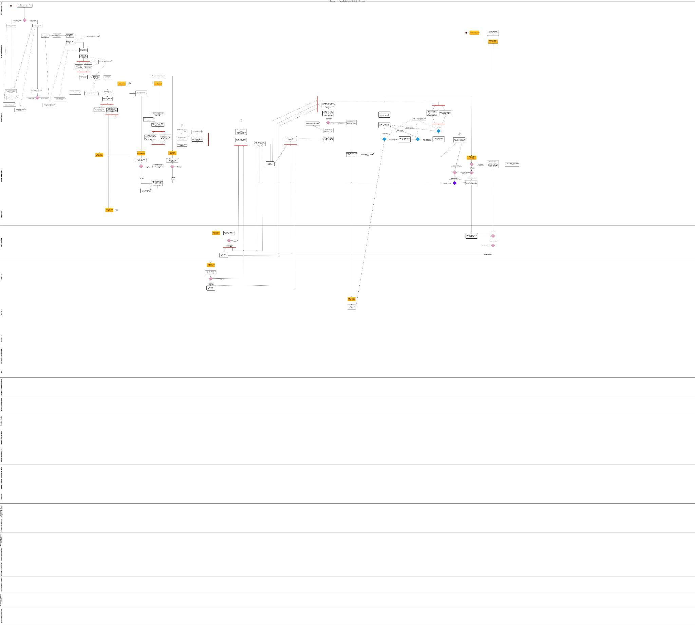
4. Swimlane Activity Diagram

